Importing Price Data to Compute the Sample Variance-Covariance Matrix

1. An Application — DOW Variance–Covariance Matrix.
This section presents another slightly more complex complete application building on the information in the preceding sections. We are going to get price data for selected stocks, compute returns, and build portfolios.
The problem can, be divided into several smaller problems

Application note.
This application is not quite ready for prime time but can serve as a basis for a more robust application. Please do not enable automatic refresh of queries if asked to do so when loading the accompanying workbook.

Get Historical Closing Price Data and monthly returns (for one company)
As a first approximation we need a VBA function to return the computed returns. In order to do its work the function needs the following parameters:
- Tickertape symbol of the company
- The starting month and year
- The number monthly closing prices we want to collect.
The following function is one possible solution. Read the comments in the function body for explanations.
Function MakeQuery(Symbol As String, StartMonth As Integer, _
StartYear As Integer, NumberOfMonths As Integer) As Variant
Dim ws As Worksheet 'Our query is going to be stored here
Dim wq As QueryTable 'This will be our query
Dim url As String 'Web address on yahoo
Dim EndYear As Integer
Dim EndMonth As Integer
Dim x As Variant 'Results
'Check and fix starting month
If StartMonth < 1 Then StartMonth = 1
If StartMonth > 12 Then StartMonth = 12
'Calculate ending year and month,
'Month is 0-11 per yahoo specifications
EndYear = _
Int((StartYear * 12 + StartMonth + NumberOfMonths) / 12)
EndMonth = _
(StartYear * 12 + StartMonth + NumberOfMonths) Mod 12
'Fix starting month, as per yahoo specifications
StartMonth = StartMonth – 1
'Combine all data into the web address on yahoo
url = "URL;http://ichart.yahoo.com/table.csv?s=" & _
Symbol & "&a=" & StartMonth & "&b=15&c=" & _
StartYear & "&d=" & EndMonth & "&e=15&f=" & _
EndYear & "&g=m&ignore=.csv"
'Add a new Worksheet store reference in ws
Set ws = ActiveWorkbook.Worksheets.Add
'Add our query to the worksheet
'results should go to column a, store reference in wq
Set wq = ws.QueryTables.Add(Connection:=url, _
Destination:=ws.Range("a1"))
'Run our query in the foreground,
'I.E wait for the query to finish
wq.Refresh BackgroundQuery:=False
'The “belt and braces” approach wait for query to finish
Do While wq.Refreshing
DoEvents
Loop
x = wq.ResultRange.Value 'Store the results
'Do NOT bother me with questions now
Application.DisplayAlerts = False
'Clean up; delete the worksheet and the query with it
ws.Delete
'DO bother me with questions now
Application.DisplayAlerts = True
MakeQuery = x
End Function

In order to run a function with parameters from the workbook a cacro is needed to supply the values for the parameters and deal with the returned data. The following acro runs the function for “IBM” for the year 2002. December 2001 is used as month zero. The macro then sets the first 20 cells in column A of the current worksheet to the returned data.
Sub mk()
Dim x As Variant
x = MakeQuery(Symbol:="IBM", StartMonth:=12, _
StartYear:=2001, NumberOfMonths:=12)
Range("a1:a20").Value = x
End Sub

Here is a screen capture of the relevant part of the worksheet.
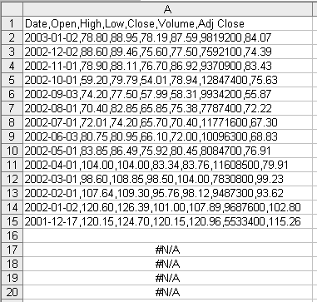
Notice that we retrieved 14 records. We have to retrieve an extra record for month 0 (row 15). The second extra record (row 2) is retrieved to solve a technical problem with YAHOO. You have to supply YAHOO with an end day and a start day even if you need monthly data, if the end day or the start day you supply happens to be after the last trading day in the month, YAHOO happily returns its entire daily database for the Symbol, regardless of your request. Sadly, we do not know the last trading day in 2002 or for that matter any last trading day. The easiest way to get around the problem is retrieve an extra half a month and ignore it.
Now the data is here but it needs processing to extract the relevant information. The following function gets the data range, splits it to separate columns, resorts it, and calculates the returns.
Function returns(rng As Range) As Variant
rng.TextToColumns Destination:=rng.Range("B1"), _
DataType:=xlDelimited, _
TextQualifier:=xlDoubleQuote, Comma:=True
rng.Columns("B:H").Sort Key1:=rng.Range("B2"), _
Order1:=xlAscending, Header:=xlYes
rng.Range("I3", _
rng.Cells(rng.Rows.Count - 2,9)).FormulaR1C1 = _
"=LN(RC[-1]/R[-1]C[-1])"
returns = rng.Range("I3", _
rng.Cells(rng.Rows.Count - 2, 9)).Value
End Function

This function works on the output of the query so the best place to call it is in MakeQuery. An added benefit is that all the temporary columns created by the function will be deleted when MakeQuery deletes the temporary worksheet. We change one line near the end of the function
Old:x = wq.ResultRange.Value 'Store the results
New:x = returns(wq.ResultRange) 'Compute returns and store the results
The new MakeQuery is called MakeQuery1. The new macro is called mk1, and here is its product.
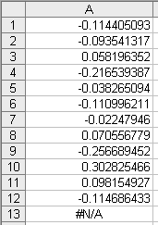

Get Historical Monthly Returns For More Then One Company.
The worksheet DOW in the chapters workbook has the names of the component symbols making the Dow Jones Composite Index (^DJA) in the first row. We now want to use the functions developed in the previous section to get the returns for some or all of the companies in the Index. Since the groundwork is done, it is a simple matter to write a macro that goes over the list and activates the functions. Here is one possible version
Sub mk2()
Dim i As Integer ' Loop index
'The names of the component symbols making the Dow Jones
'Composite Index are in Worksheets("DOW").Range("A1:AY1")
For i = 1 To 51 'Loop over the symbols
'Worksheets("DOW").Cells(1, i).Value is the symbol
'Worksheets("DOW").Cells(2, i).Range("a1:a51").Value
'are the 51 cells under the symbol
Worksheets("DOW").Cells(2, i).Range("a1:a51").Value = _
MakeQuery1( _
Symbol:=(Worksheets("DOW").Cells(1, i).Value), _
StartMonth:=12, StartYear:=1999, NumberOfMonths:=60)
Next i 'End of Loop over the symbols
End Sub

It takes a while (from 20 seconds to 5 minutes depending on the speed of your internet connection and the load on YAHOO) but when control returns to the workbook a very dense table of numbers appears. Here is the top left corner of the DOW worksheet.
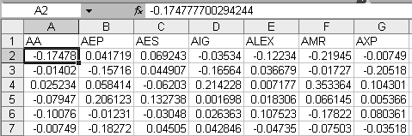
This is the returns data for the Index. In a real life application now would be the time to do some sanity checks, but again for brevity’s sake we shell forgo the pleasure (and the pages of dense VBA code that it necessitates).

Compute the Variance–Covariance Matrix
Cells A2:A11 in the worksheet fm3_chapter41_var_cov.xls were set up as selection boxes for symbol names from the list of symbols in the worksheet DOW. Conditional formatting was used to highlight mistakes in data entry. Here is a snap shot of the worksheet with some mistakes in data entry and one of the selection boxes open.
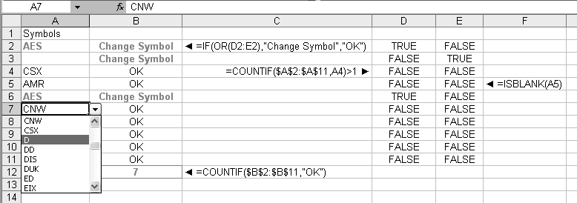
And here is the same view with the addition of the original row numbers and all the data entered properly.
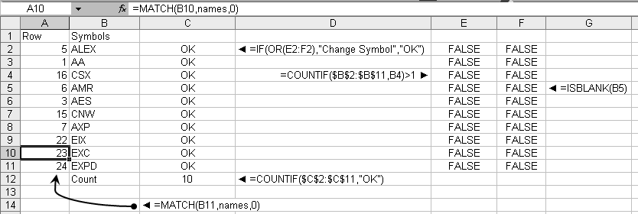
We now want to create the Var–Covar matrix for these symbols. Since we are going to be dealing with a lot of numbers we shall use a more efficient and less clear variation on the function introduced in section 8.4.
Function VarCovar(rngSym As Range) As Variant
'The number of symbols should actually be calculated from
'rngSym but will get to this nicety later
Const numCols = 10
'The range of returns this also should be a parameter and
'again will get it later
Dim rng As Range
Dim Sym As Variant 'Symbol column numbers
Dim i As Integer 'Loop index
Dim j As Integer 'Loop index
Dim Mat(numCols, numCols) As Double 'the Matrix
Set rng = Worksheets("DOW").Range("A2:AY52") 'see above
Sym = rngSym.Value 'Convert range to array
For i = 1 To numCols 'For all the symbols
For j = 1 To i - 1 'For the top triangle
Mat(i, j) = Application.WorksheetFunction.Covar( _
rng.Columns(Sym(i, 1)), rng.Columns(Sym(j, 1)))
Mat(j, i) = Mat(i, j)
Next j 'End for top triangle
Mat(i, i) = Application.WorksheetFunction.VarP( _
rng.Columns(Sym(i, 1)))
Next i 'End for all symbols
VarCovar = Mat
End Function

Because this function uses only data already in the workbook we do not need a macro to activate it. The functions can be entered as an array function on the worksheet. Here it is; some columns are hidden for clarity before the screen was captured. The column and row headers are also functions of the original selections, and everything will get recalculated if you change the participating symbols.
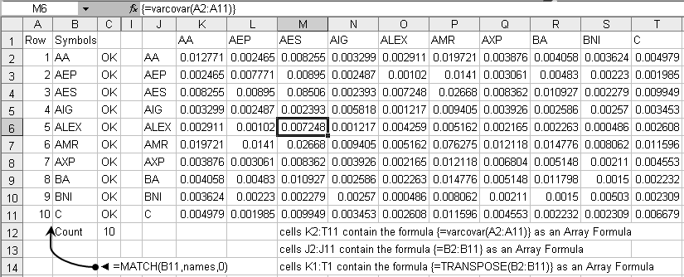
One small modification later and we have the mean returns as well
